**Dual Booting Exercises:**

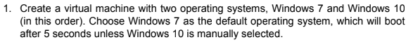

To do this exercise first we have to install the windows 7 iso first and then the windows 10 iso.

When we have installed the both OS we have clic in the **“Change defaults or choose other options”** choice

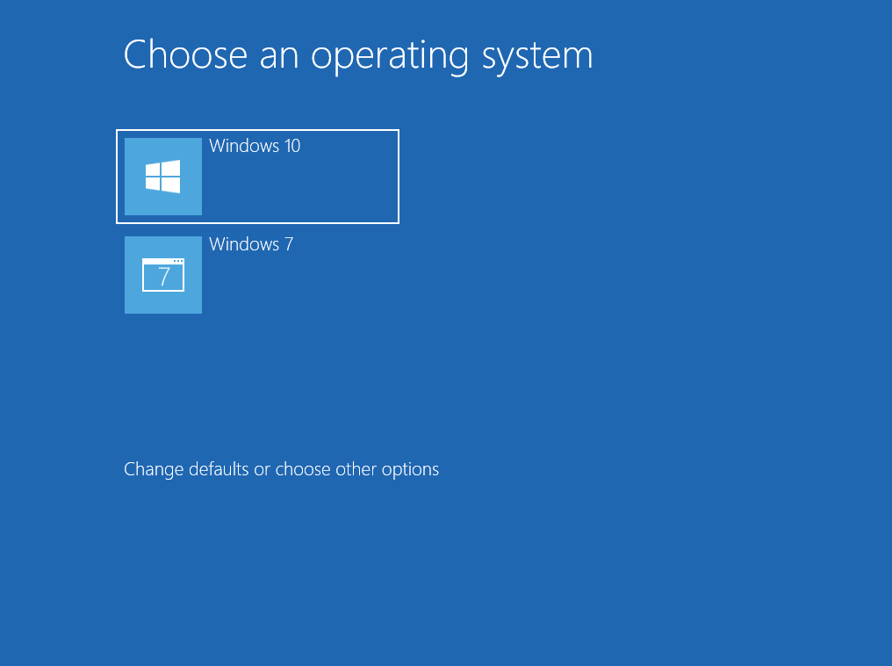



Then, for choose the default option we have to select the second option of this menu:

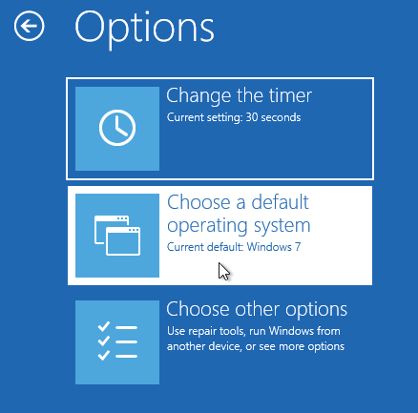

Now we have to select the OS that we want to be the default option.

In this case we want windows 7 for be the default option:

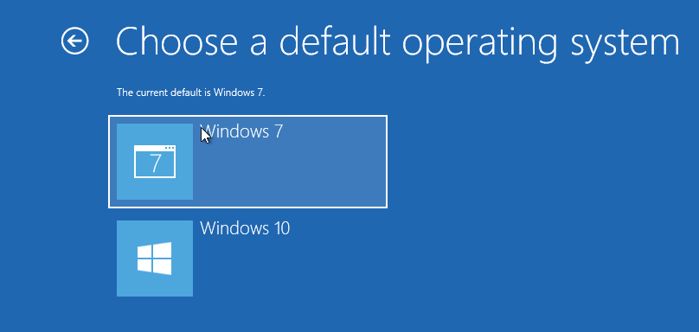

The next step we are going to change the time for boot:

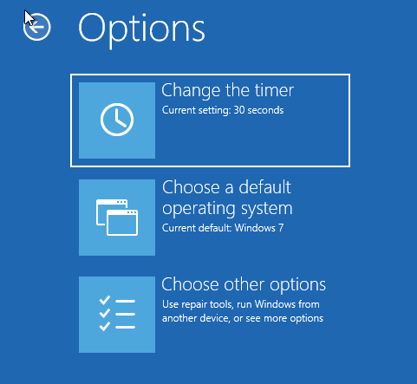

Now we are going to put 5 seconds in the following menu:

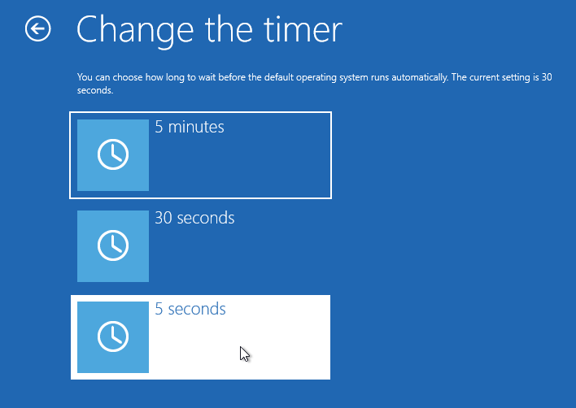

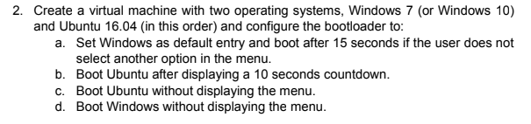

**A.**First we are open up the console of the ubuntu system and we are going to write this command to be a super user to change the boot options:



before we are in super user, we are going to write the path of the boot options:



Then we have to change some options in our case we are going to change the default OS entry and the automatic OS that start when we don't select any option:

To put the default option for boot in windows we have to change the **“GRUB_DEFAULT=5”:**



Now we are going to change the automatic boot for this we have to change the **“GRUB_TIMEOUT=15”**



**Don’t forget to apply the changes we have to do the update-grub after we modify this path:**

**/boot/grub/grub.cfg**

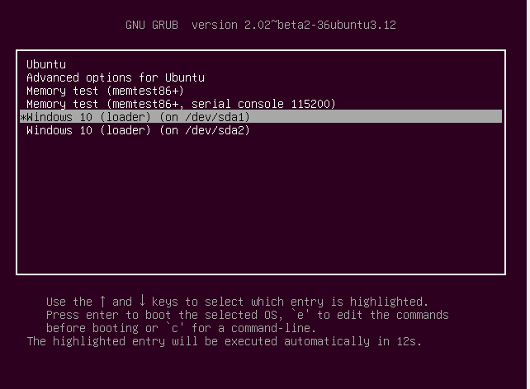

**B.** Now we are going to change the options to boot ubuntu displaying the 10 seconds countdown

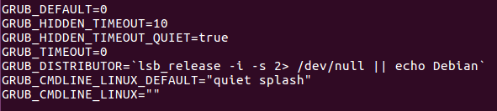**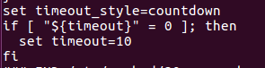\***



**C.** Now we are boot Ubuntu without displaying the menu

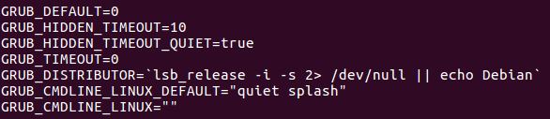

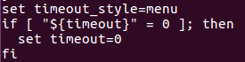

**D.** Now we have to the same but booting windows



